NFT Marketplace App

Project Report

# Under the Supervision of

**Dr. Sushil Panwar**

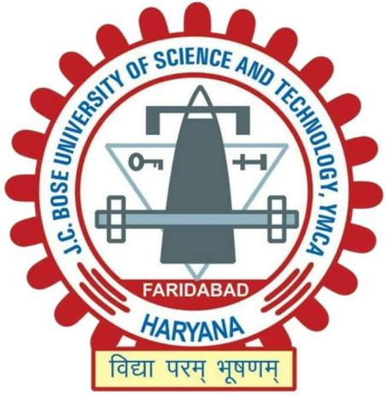

# Department of Computer Engineering

JC Bose University of Science & Technology, YMCA, Faridabad

(Dr. Sushil Panwar)

|  |  |
| --- | --- |
| **Progress Report (1st/2nd/3rd/Final)** | **Final** |
| **Name and Roll Nos. of Students** | **Dev Kumar Gupta(20001003035)**  **Abhinav Yadav (20001003002)** |
| **Task Accomplished:**  Project Snippets -  Screenshot 2022-08-02 at 4.04.47 PM  Screenshot 2022-08-02 at 4.05.05 PM | |
| Screenshot 2022-08-02 at 4.05.33 PMScreenshot 2022-08-02 at 4.05.15 PM | |

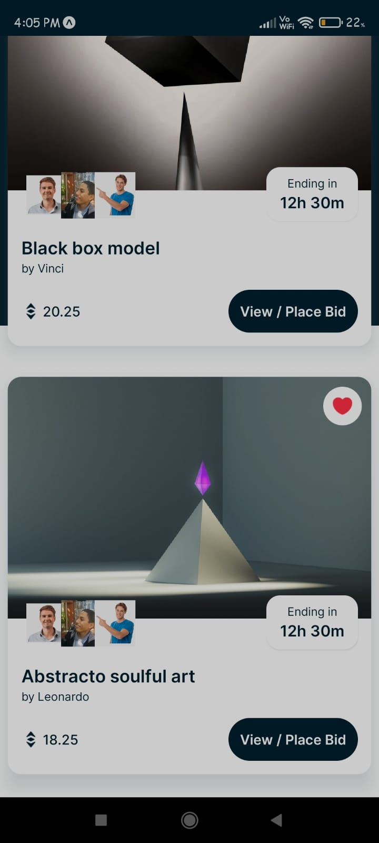

## WhatsApp Image 2022-08-02 at 4.06.09 PM

## Tasks accomplished :

1. Created and posted masterpiece art for showcasing;
2. Shows potential buyers and their starting price;
3. Real-time countdown and live price sharing;
4. Created individual pages for respective art pieces;
5. Each page holds related information and shows interested buyers;
6. Shows all the key info about the buyers.

## Tasks to be accomplished :

1. Create a like system for users to interact with each other;
2. All tasks accomplished.

|  |  |
| --- | --- |
| Our mentor, *Dr. Sushil Panwar*, actively contributed in our project flow by providing valuable feedback and suggestions for improvement, which we surely will focus upon implementing and integrating to our project.  Our project coordinator, Dr. Sapna Gambhir also provided useful information and feedback for improvements on our project. | |
| **Comments of the supervisor** |  |
| **Date of submission to**  **Project Coordinator** |  |